›

| **Team Number** | 08 | **Section** | 03 |
| --- | --- | --- | --- |
| **Team Members** | 1. Justin Goodman 2. Brenda Casas 3. Jimin Song 4. Byung Moon Kim | | |
| **Software Name** | Better Student | | |

## Introduction

* 1. **Objective** [10 Points]

This technical spec document is an official description of the softwares components written by software designers and readable by software developers.

* 1. **References** [5 Points]

https://docs.oracle.com/javafx/2/overview/jfxpub-overview.htm

## Software Overview

**2. 1. Problem Statement** [10 Points]

* Students nowadays have been struggling with school all around the world due to this pandemic going on, and students have trouble focusing and doing their best work because of online schooling.
* Students aren’t achieving as high of grades as normal due to the pandemic.
* On top of having trouble staying focused, students are also not taking proper care of themselves with eating, sleeping, and hours studying.
* Current software is related to students' GPA success and health are either not worth the user’s money or they are hard to use and don’t give beneficial advice.
* Advice on how to achieve higher grades and how to take proper care of oneself can be achieved through software to help students along the way.

**2.2. Scope** [5 Points]

* All students who have computer and internet access will be able to use this software.

**2.3. Technological Requirements** [10 Points]

* This software will incorporate Java, and JavaFX.
* A flexible and easy to use software would fill the gap of the correlation between achieving higher grades/GPA and taking care of oneself.
* Track eating, sleeping, and studying to see how the individual is.
* Give a survey on their current habits and lifestyle and give personalized advice on how they can do better.
* Users' data would be stored permanently until they choose to add, delete, or change their data input for a renewed personalized advice.
* Running it shall be easy and won’t need installing anything else.
* It shall run on all existing OS’s (windows, mac, linux) with JavaFX.
* Future plans would be to modify the software to let users know they could benefit from more sleep, more meals eaten, and more hours studied, depending on their GPA.

## Detailed Design

**3.1. UML Class Diagrams** (for all classes) [20 Points]

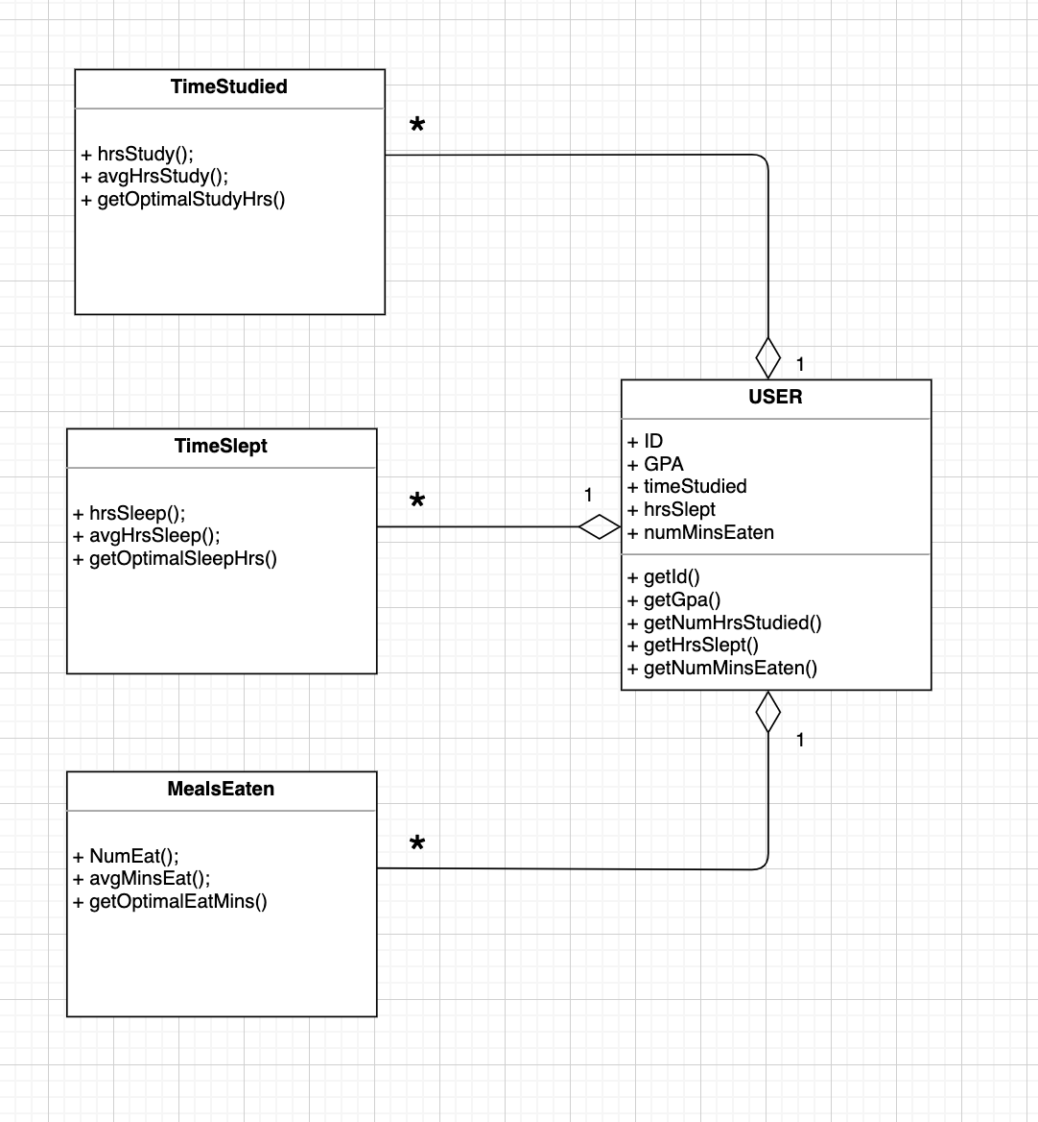

**3.2. UML Sequence and/or State Diagrams** (at least one of them) [15 Points]

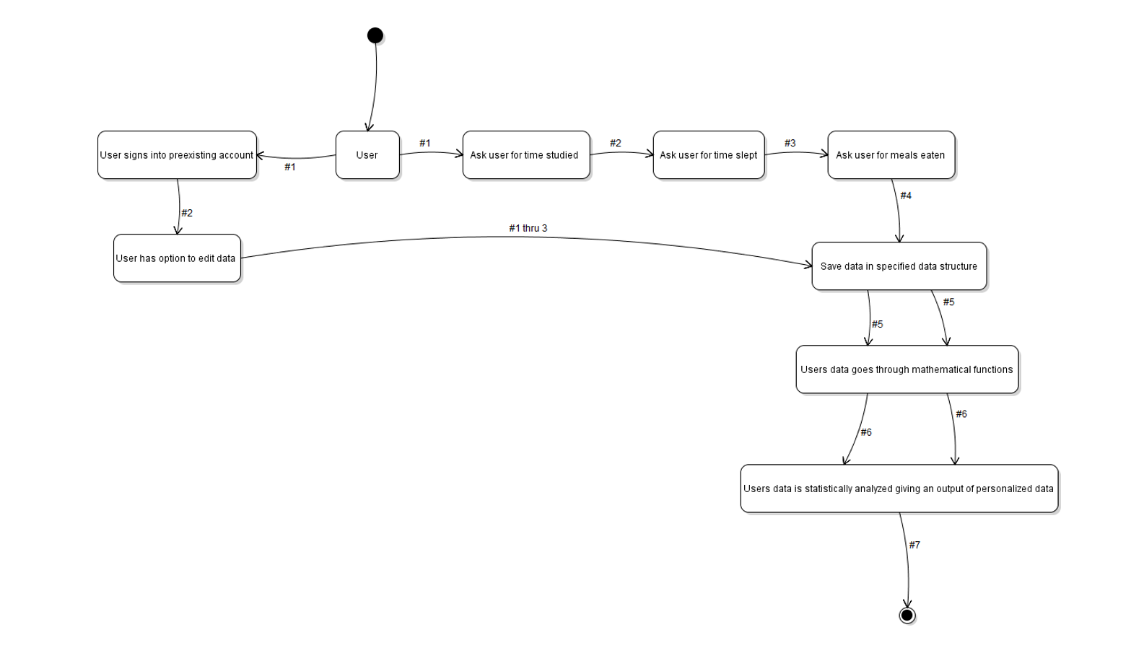

**3.3. User Interface** [15 Points]

User “Login” View

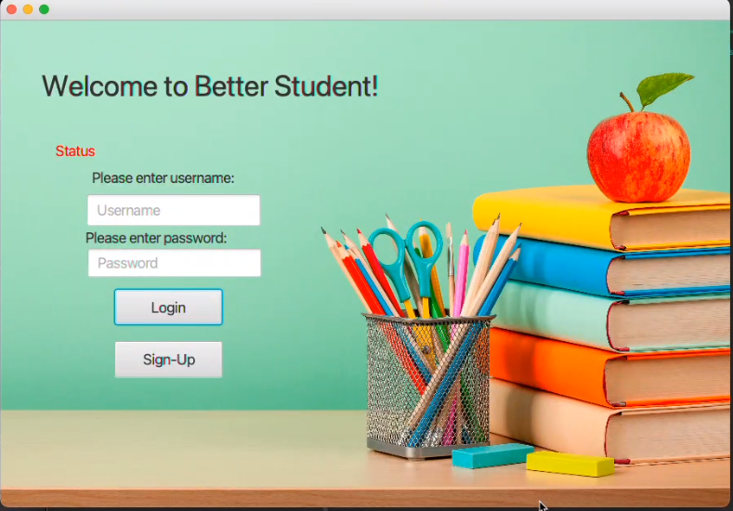

User Sign-Up View



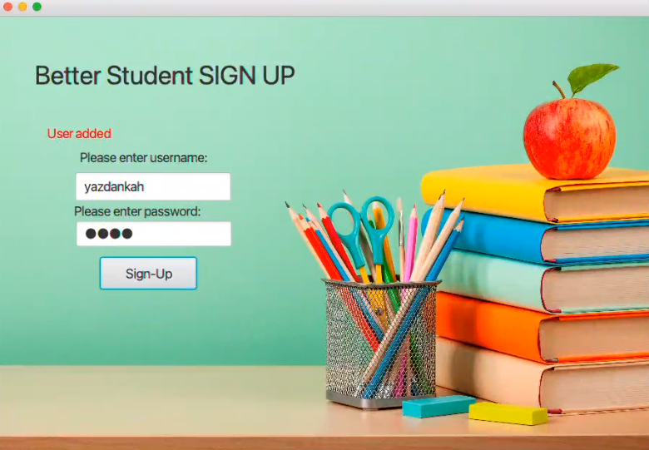

After logging, user gets redirected to the “Main Menu” view and can chooses between buttons

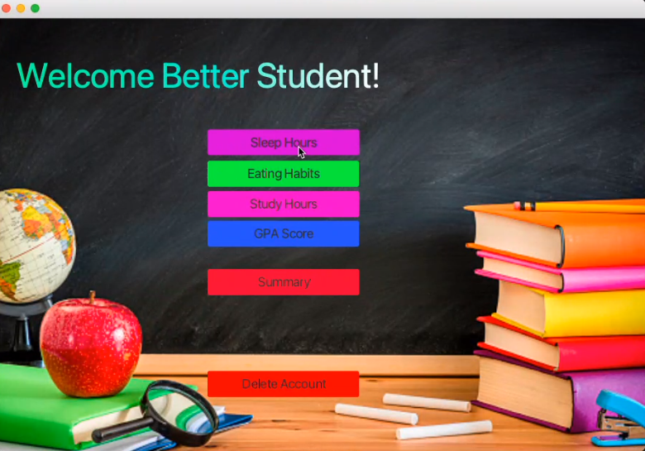

Sleep Hours Page

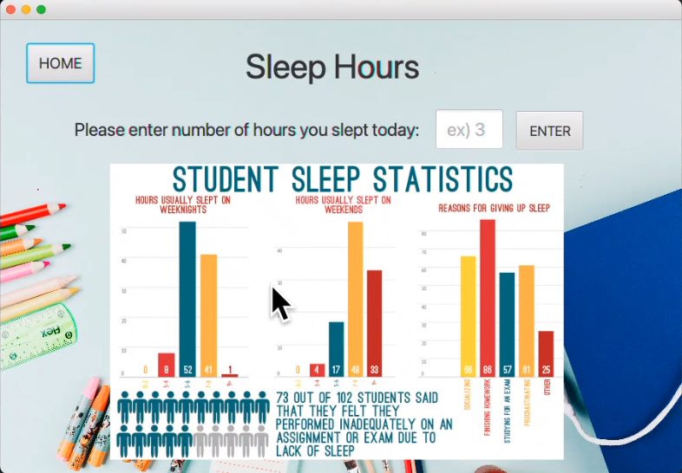

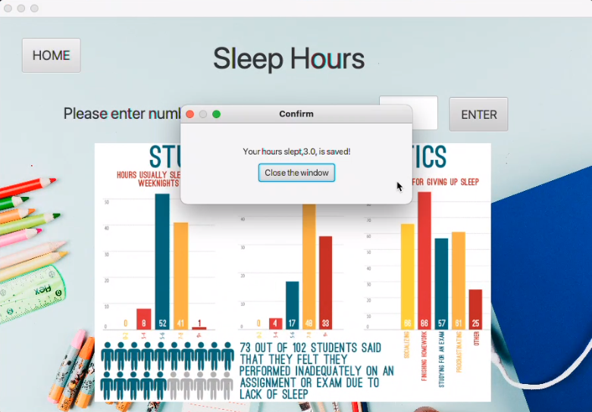

Eating Habit View

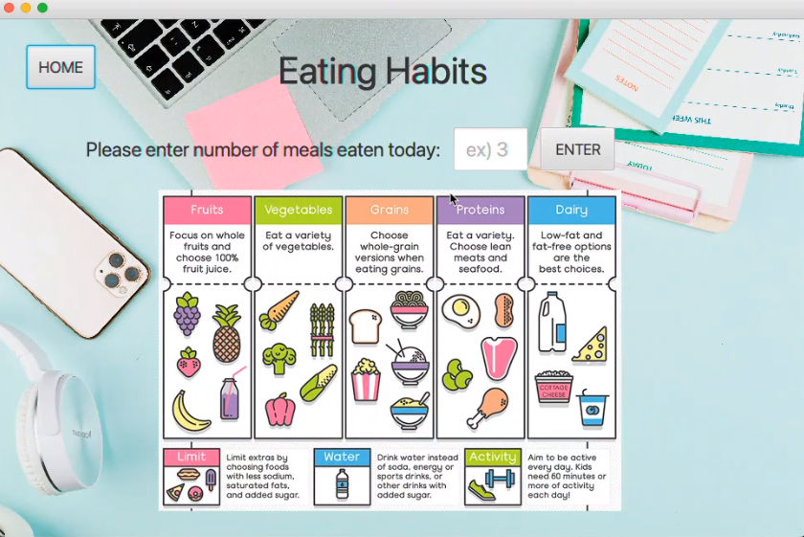

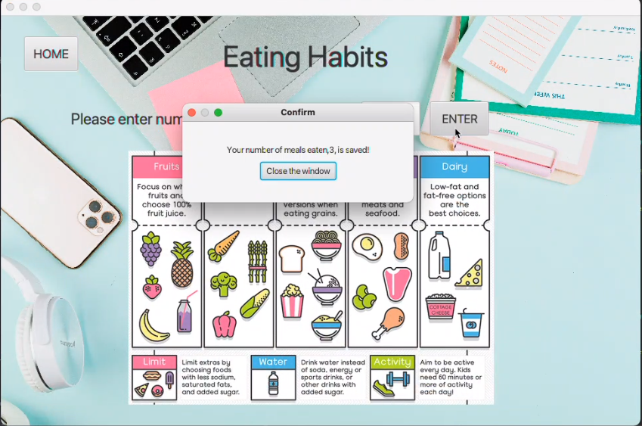

Study Hours View

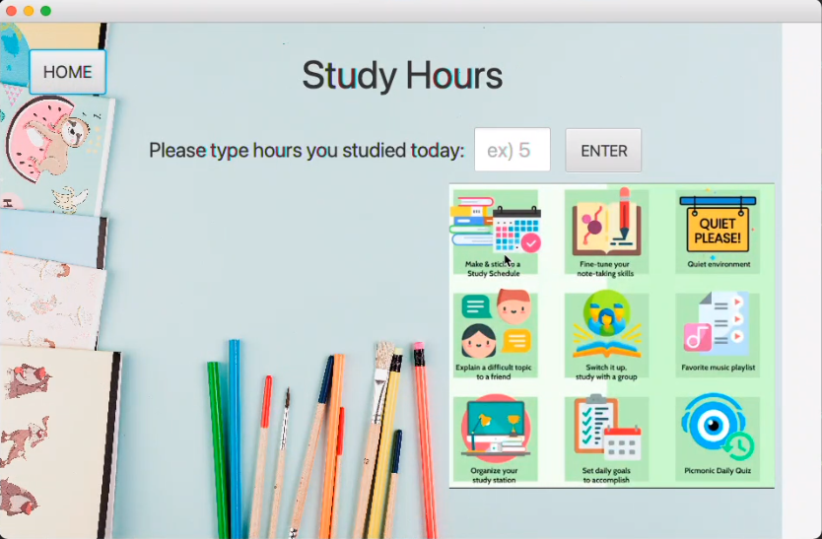

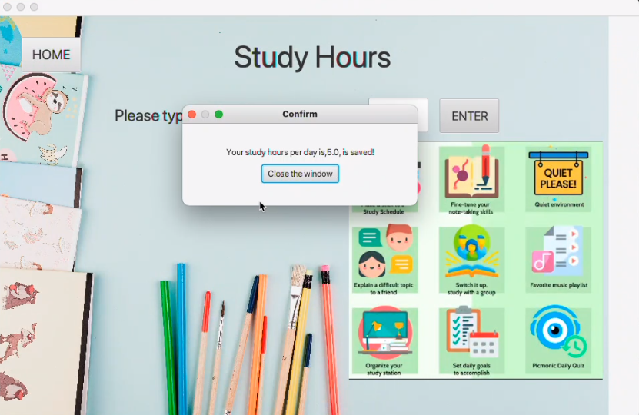

GPA Score View

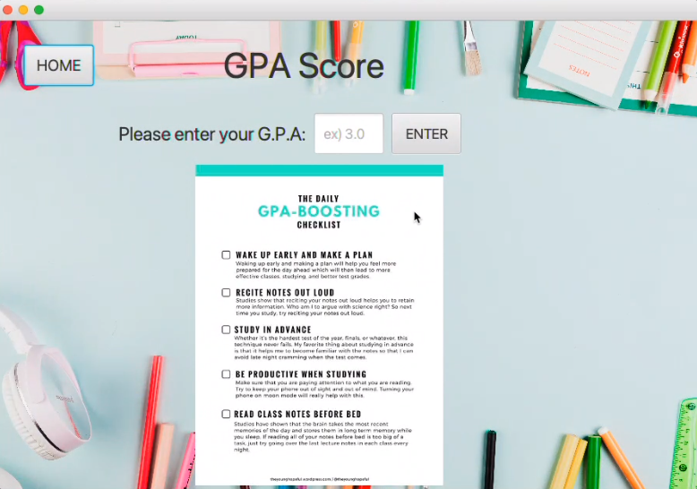

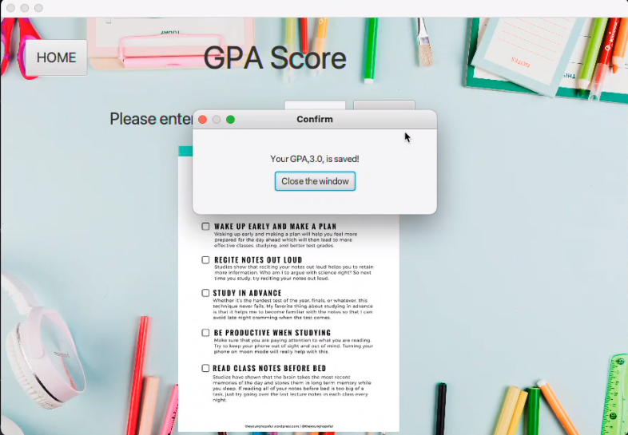

Summary View

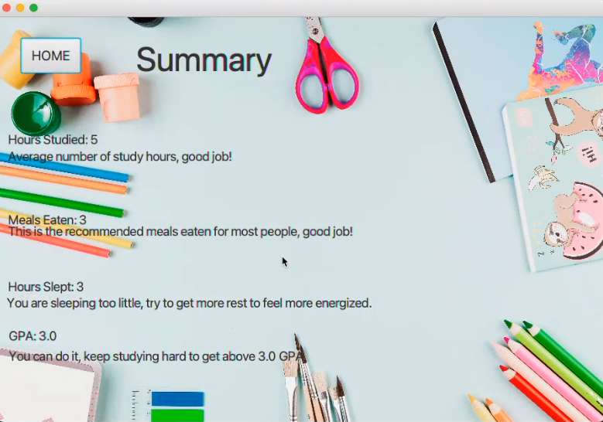

Delete Account

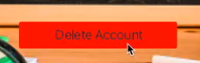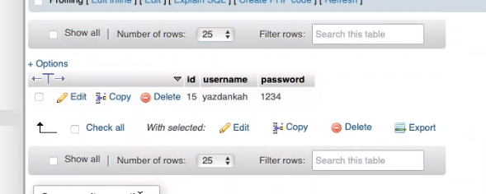

Account is deleted

